**Starting an Inventory Management System (IMS)**

Go to Start -> All Programs ->Inventory Management System -> inventory Management System. Then click.

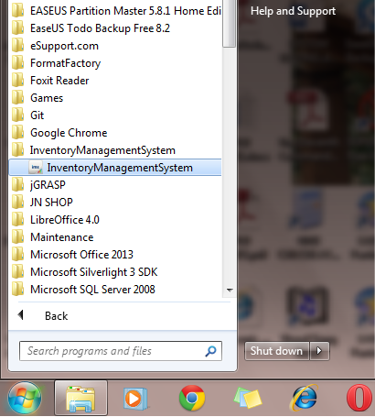

**Login Screen**

To use the system, enter **username** and **password** then click **LOGIN.**

If this is the first time to use the system after installation, then use the default username and password to get started. *(default username:* ***admin*** *and default password:* ***admin****)*

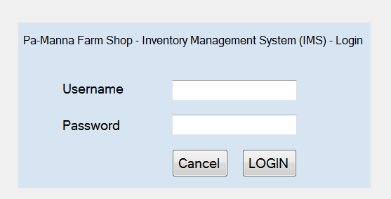

**You are logged in**

Main navigation menu looks as below. We will go through them one by one.

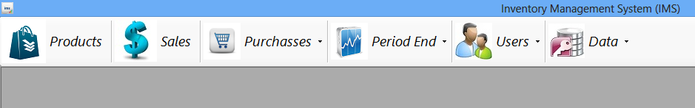

When you have just logged in, the first window you see is **Notice Board**.The left section of the window is **Pay Your Suppliers.** This section shows your suppliers who have passed the payment date (**Past Due),** are to be paid today (**Due Today)** and those who are to be paid very soon (**Due Soon).** By default, Due Soon shows suppliers (GRNs) which are payable within five days. You can change that by clicking **menu** down arrow (in the status bar), then **settings.**

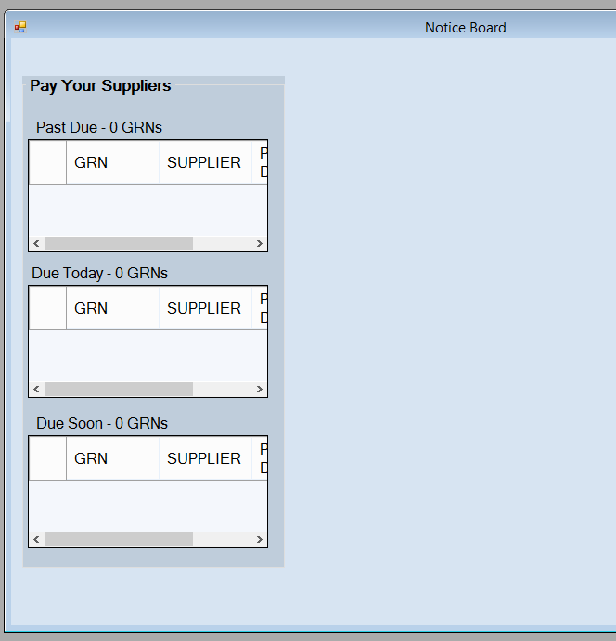

Close **Notice Board** window

**Users**

First thing to do is to change default username and password and add other users.

To do that click **Users** tab

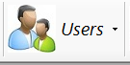Three sub menus appear.

**Change Password**

This allows you to change your current password. It is important to change passwords if you suspect that someone knows your password. Clicking this menu will make **Change Password** window to appear

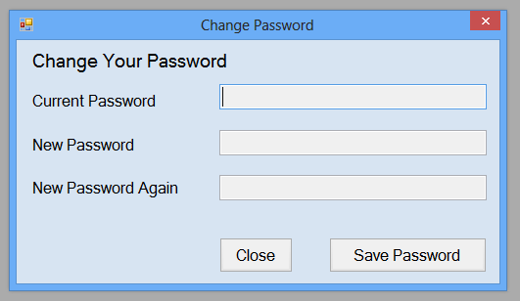

Enter your password you are currently using and new password twice and click **Save Password** button to change it.

**Manage Users**

This menu is used to add, edit, activate and deactivate users. Clicking this menu brings up the following window

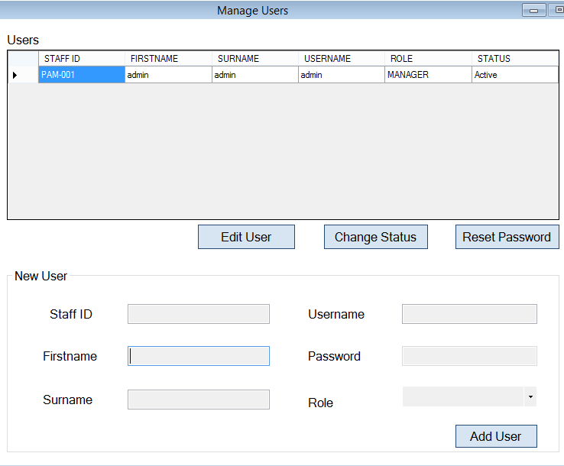

***Editing a User***

By default you have a user username **admin*.***

* Select the row and click **Edit** button to edit the user details.

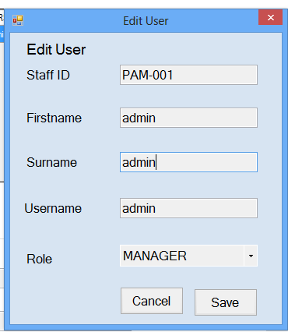

Enter your details and click **Save.**

**WARNING!!! Never never change the role of MANAGER to CLERK unless you have added a new user with a role of MANAGER. OTHERWISE YOU WILL LOCK YOURSELF OUT OF THE SYSTEM**

***Adding a User***

* To add a new user enter user details and click **Add User** in the **New User** section
  + **NOTICE: Different users should have different Staff IDs and usernames**
* Give username and password to the owner.
* Let the users change their password when they have successfully logged in for the first time.

***Resetting a password of a User***

Sometimes the user may forget the password. So the user with a role of a **MANAGER** can reset the password of that user.

**WARNING!!! Manager should never never forget their password**

To reset the password:

* Select the row of the user.
* Click **Reset Password** button. You will be presented with a confirmation window
* Click **Yes** to confirm. *The password will be reset to the username of the user.Now the user can login by typing their username for password*

***Activating/Deactivating a User***

A user can be deactivated or activated using **Change Status** button.

* Select the row of the user.
* Click **Change Status** button. You will be presented with a confirmation window
* Click **Yes** to confirm.

**Change Password**

**Products**

After adding users, second thing to do is to add your products.

* Click **Products** tab



* The **Products** window appears. Some of the buttons on products window are shown below

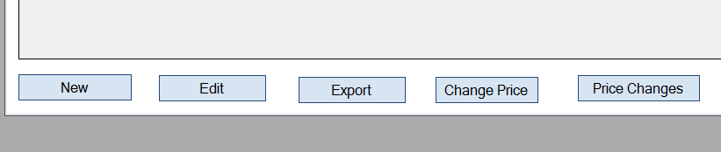

* First add categories by clicking **Categories** button. The window changes as shown below (Small window **Product Categories** appears.)

**NB:** These categories can be departments of your products etc. for example you may choose to categorize your products as Leaf Vegetables, Fruit Vegetables, Meat Family, etc.

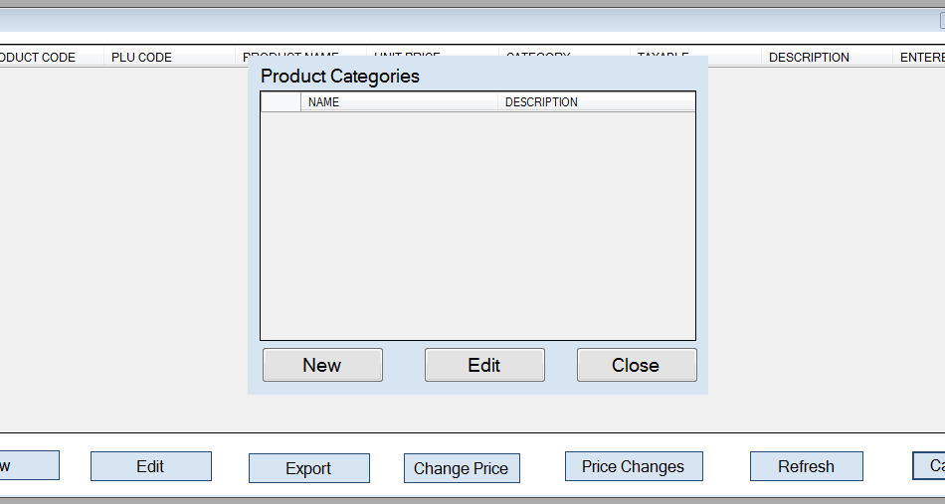

* Click **New**. The window changes as below.

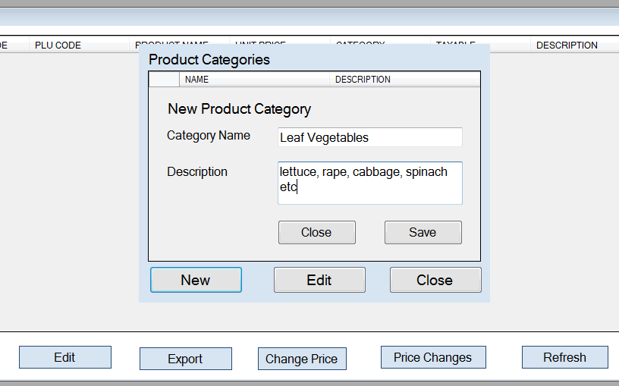

* Enter **Category Name** and **Description** (optional), then click **Save.** You are back to small window of **Product Categories.** The Added Category appears.

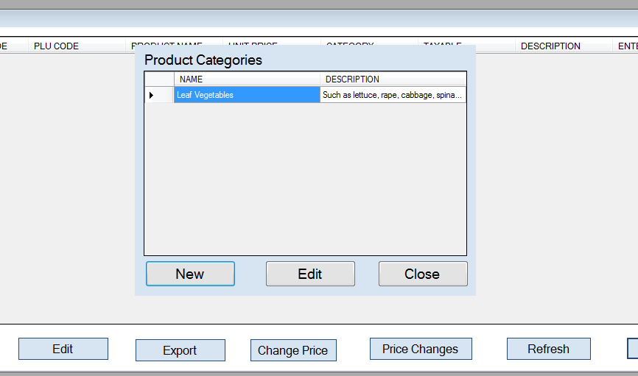

* You can edit **Product Category** by select product category row and click **Edit** button
* Add as many categories as you have. When you are done adding categories, click **Close** button of the small window. You are back to Products main window
* Now you can start adding products by clicking **New** (first button from the left). New product window appears.

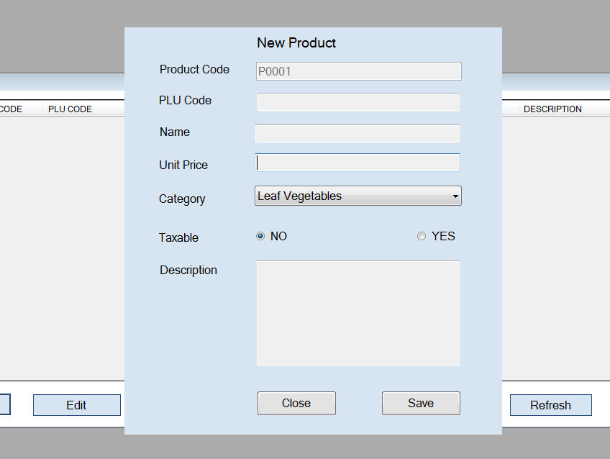

* Enter all details such as PLU Code, Name, Unit Price etc. Only Description is optional. Then click **save.**
* Enter as many products as you have. Click **Close** to dismiss **New Product** window. You are back to the main **Product** window.
* Click **Refresh** button to view all added products
* To edit a product, highlight a product row then click **Edit.** (You can also just double click the row to edit). See below

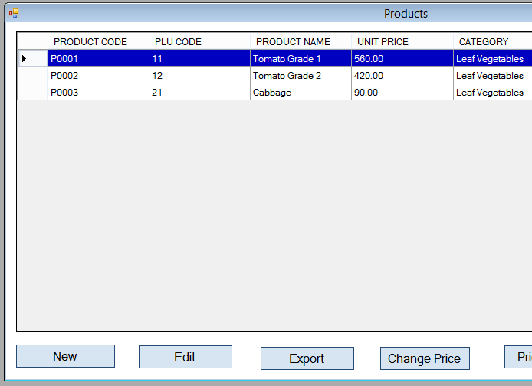

* The whole list of products can be exported to Excel file using **Export** button. (It may take a while to complete exporting data to excel depending on your computer. So be patient)
* To change the unit price (selling price) of the product, select the product row first and then click **Change Price.**

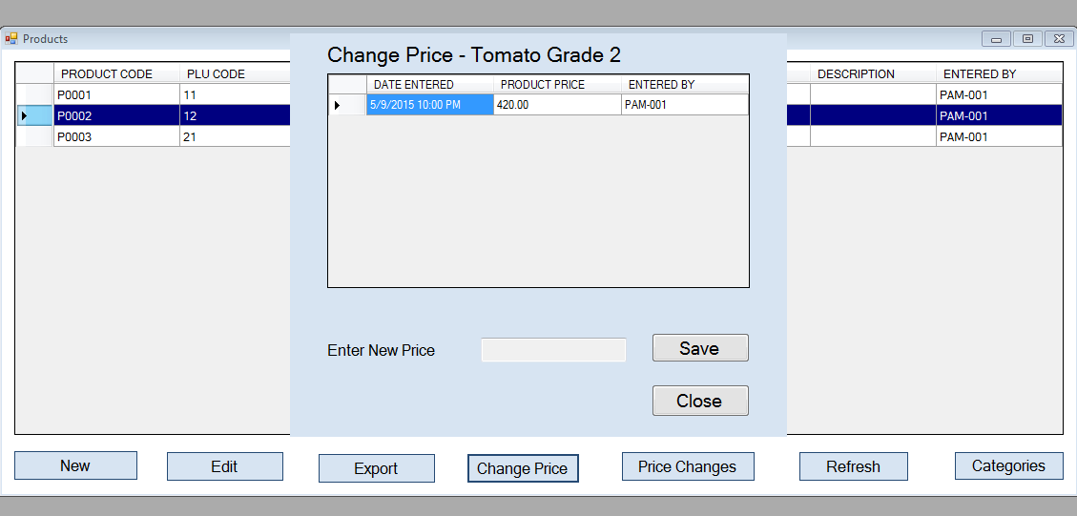

* **Price changes** button views all changes made to all products per month per year

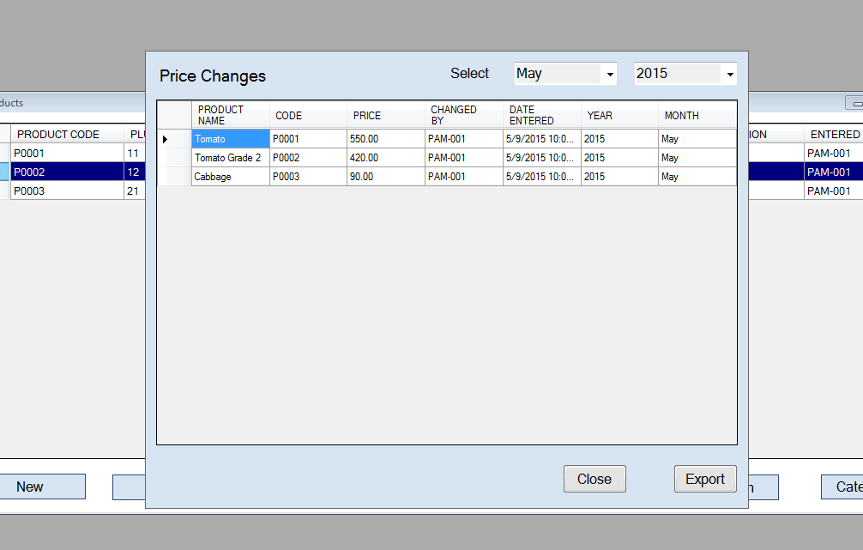

You can also **export** the list of **price changes** by clicking **Export** button